Silahkan memilih salah satu dari lima proses bisnis yang terdapat pada <https://bit.ly/3vUspMs>.

Tugas anda sebagai konsultan adalah untuk merancang data warehouse dengan memanfaatkan ERD yang ada pada proses bisnis yang dipilih.

1. **Rancanglah enterprise bus matrix** berdasarkan proses bisnis dan ERD yang dipilih. **(10%)**

**Jawaban:**

1. **Rancanglah diagram star** atau snowflake atau constellation schema sesuai dengan kebutuhan dan hasil analisis dari proses bisnis dan ERD yang dipilih. **(15%)**

**Jawaban:**

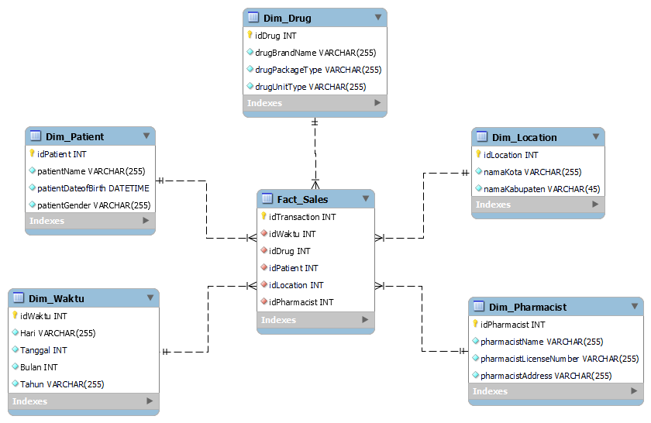

1. **Rancanglah proses untuk Extract, Transform, Load (ETL)** dari ERD yang dipilih ke sistem data warehouse yang dirancang. Anda dapat menggunakan tabel dibawah sebagai contoh format proses ETL. **(15%)**

**Jawaban:**

|  |  |  |  |
| --- | --- | --- | --- |
| **Source tables** | **Destination table** | **Transformation** | **Remark** |
| Patient | Dim_Patient | Select to make all the required attributes that are available in the source table transformation available in the sub-transformation. |  |
| Manufacturer, DrugItemPackage, Drug, DrugItem | Dim_Drug | Select to make all the required attributes that are available in the source table transformation available in the sub-transformation. |  |
| Client Health-Care Organization, Client Unit | Dim_Location | Select to make all the required attributes that are available in the source table transformation available in the sub-transformation. |  |
| Pharmacist, Order, Client Health-Care Organization, Client Unit | Dim_Pharmacist | Select to make all the required attributes that are available in the source table transformation available in the sub-transformation. |  |
| Prescription, Order | Dim_Waktu | Select to make all the required attributes that are available in the source table transformation available in the sub-transformation. |  |

1. Implementasikan table data warehouse yang anda rancang dengan menggunakan RDBMS pilihan anda. **Minimal setiap dimensi ada 15 records, dan fakta ada 50 records**. **(25%)**

**Jawaban:**

**Dim_Waktu (61 Records)**

**Dim_Drug (18 Records)**

**Dim_Location (15 Records)**

**Dim_Patient (15 Records)**

**Dim_Pharmacist (15 Records)**

**Fact_Sales (755 Records)**

1. **Rancanglah dashboard BI untuk data warehouse yang anda rancang** dengan menggunakan tools pilihan anda. Jelaskan juga perancangan anda. **(35%)**

**Jawaban:**

|  |  |
| --- | --- |
| **Nama Kueri** | **Proses Kueri** |
| Transaksi per Bulan | SELECT [Measures].[Fact_Sales Count] on Columns, NON EMPTY order({[Dim_Waktu].[Bulan].[1], [Dim_Waktu].[Bulan].[2], [Dim_Waktu].[Bulan].[3], [Dim_Waktu].[Bulan].[4], [Dim_Waktu].[Bulan].[5], [Dim_Waktu].[Bulan].[6], [Dim_Waktu].[Bulan].[7], [Dim_Waktu].[Bulan].[8], [Dim_Waktu].[Bulan].[9], [Dim_Waktu].[Bulan].[10], [Dim_Waktu].[Bulan].[11], [Dim_Waktu].[Bulan].[12]}, [Measures].[Bulan], ASC) on Rows FROM [Dim_Waktu]; |
| Transaksi per Kota | SELECT [Measures].[Fact_Sales Count] on Columns, NON EMPTY order([Dim_Location].[Nama Kota].members, [Measures].[Dim_Location Count], ASC) on Rows FROM [Dim_Location]; |
| Transaksi per Produk | SELECT [Measures].[Fact_Sales Count] on Columns, NON EMPTY order ([Dim_Drug].[drugBrandName].members, [Measures].[Fact_Sales Count], DESC) on Rows FROM [Dim_Drug]; |
| Transaksi per Jenis Kelamin | SELECT [Measures].[Fact_Sales Count] on Columns, NON EMPTY order ({[Dim_Patient].[patientGender].[Pria], [Dim_Patient].[patientGender].[Wanita]}, [Measures].[Fact_Sales Count], DESC) on Rows FROM [Dim_Patient]; |

**Hasil Dashboard Menggunakan Tools Tableau:**

**Materi yang dikumpulkan:**

- Softcopy star atau snowflake, atau constellation diagram

- Softcopy tabel source to target mapping proses ETL

- Script SQL untuk membuat masing-masing tabel fakta dan dimensi

- Softcopy screenshot dashboard BI